**G.8 output:**

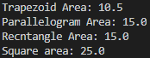

**G.17 output:**

public double getPaymentAmount() {

        return this.earnings();

    }